Table of Contents
Client Discovery 2
Personal Information 2
Discovery Session 2
Coaching 2
Career 3
Personal 3
Focus areas 4
Final Question: 4
Goals 4
Fitness 4
Relationships 4
Finance 4
Fulfillment 5
Values 5
Purpose Statement 5
Vision(s) 5
Captain 5
Crew Members 5
Actions 5
Homework 5
Personal Development plan 5

Client Discovery
Congratulations! You have chosen to be a Kickass Coaching client. In our eyes, you have the desire, commitment, dedication, and potential to become a your version of “kickass”; to sacrifice what kickass people sacrifice, to take dramatic action all to meet your kickass goals. We believe in you; you can do it.

Note; All information shared between the coach and client is strictly confidential

Personal Information

Name:
Best Phone Number:
Next Best Phone Number:
Mailing Address:
Email:
DOB:
Relationships (Name and relationships of significance to you; spouse/partner, children, family friends, colleagues etc.)

Discovery Session
A discovery session is a kick off session (approx. 90 mins) where we will set the groundwork for what we will work on and what you hope to get out of this. We will cover:
- What is coaching and what you can expect
- What we are agreeing to together (our coaching agreement)
- What is working and what is not…(questions above will provide insights here)
- Your future – define what success looks like and how will you know.
- Coaching – maybe but this is more discovery than coaching – we will focus on coaching in our upcoming sessions.
Thank you for considering these questions ahead of time. Please send them back to me via email.
I can’t wait to get started as your partner in achieving your dreams and desires.

Coaching

Almost every champion has a coach; and almost no coaches do workouts for their players, or score points / goals to win any championship. You as the client do the work, you run the sprints, you execute the play that wins your championship. Your coach is there every step of the way with you but you do the work.

The client is responsible to provide feedback and tell the coach what you need. No one knows you better than you do and you are unique and different from everyone else; you are the only you! Help us help you.

As your coach, it’s important to get a sense of how you view the world, and yourself in the world. Each person has his/her own unique way of perceiving the world, and has a unique way of interacting with others.

The following questions are designed to help get to know you better. They are designed to be pondered and to stimulate your thinking in a way that will make our work together productive and rich. I suggest you chew on the questions for a few days before you compose your responses.

- What do you expect to get out of this coaching relationship?

- Why did you choose to work with me?

- If coaching were to have a huge impact on you what would the outcomes look like?

- Where are you Evasive and how will I know?

- How should I address avoidance?

- We all get in our own way… How do you get in your own way? (Ie. Doing it yourself, stubbornness, having to be right, procrastinating, tolerating?)

Career

- What do you want from your current career?

- What are your career aspirations?

- What are you great at and better than other people at?

- What skills / knowledge are you working on?

- Other?

Personal

- Look forward 20 years… you are attending a function where someone is giving a speech about YOU! What would you want them to say?

- If time and resources were not a concern, describe the things you long to do.

- Think about one or two people you know who really inspire you. What about them is inspiring?

- What’s missing in your life, the presence of which would have your life be more fulfilling?

- What would you do if you knew you could not fail?

- What two steps could you immediately take that would make the biggest difference in your current situation?

- When are you unable to laugh at yourself?

- When do you give your power away? To whom?

- What drives you crazy?

- What do you contribute that is unique? Or What special knowledge do you have?

- What can I say to you when you are “stuck” that will return you to action?

- If you trusted your coach enough to say how to manage you most effectively, what tips would you give?

Focus areas
Identify 3 - 5 focus areas for our coaching work together and define a measurable result:
1.
Measureable result:
2.
Measureable result:
3.
Measureable result:
4.
Measureable result:
5.
Measureable result:

Final Question:

- What else would you like me, as your coach, to know about you?

Goals

Fitness

Relationships

Finance

Career

Fulfillment

Values

Purpose Statement

Vision(s)

Captain

Crew Members

Actions and Time Log

Homework

Personal Development plan

Actions for this Exercise, please move the star to give yourself a score on the Professional or Job wheel below:

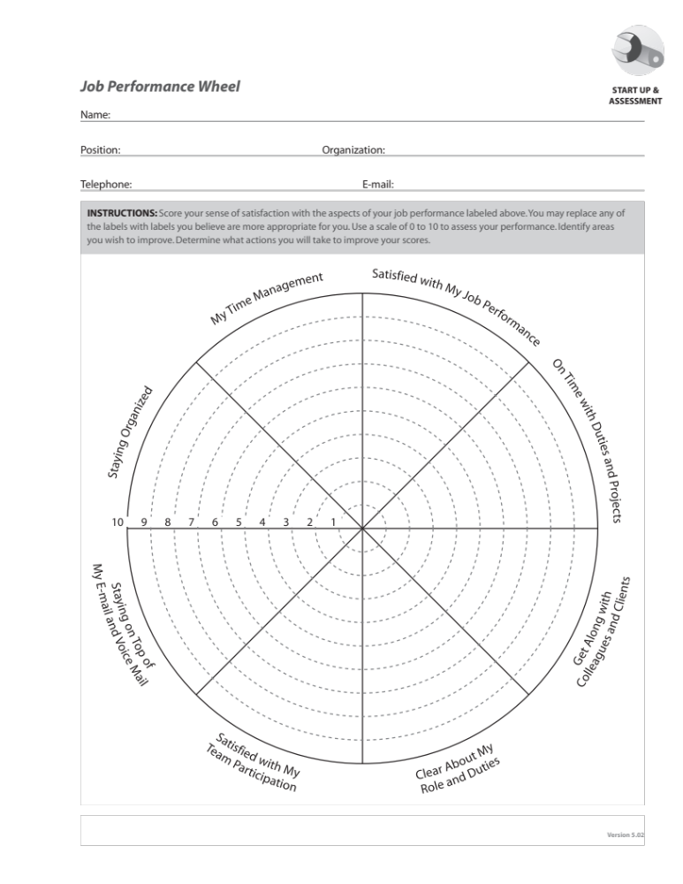

Actions for this Exercise, please move the star to give yourself a score on the Personal or life wheel below:

