Intentional Living
&
Selling Yourself

Kick Ass Coaching
Thornhill, Ontario
Adam 647-929-7179 Adam@kickasscoaching.ca
Courtney 905-597-7179 Courtney@kickasscoaching.ca

Intentional Living Table of Contents
Introduction on Intentional Living and selling yourself 3
Prioritize your life in line with your values 3
Selling yourself your business 4
Career perspective check lets go back to school 4
Appendix 1 – Exercise - Values 5
Step 1 – understand your values: 5
Step 2 – declare your values: 5
Step 3 – Align your values 5
Step 4 – Plan your life around your values 5
Value List 6
Appendix 2 - Life Wheel 7
Appendix 3 – Job Wheel 8
Appendix 4 - The P.I.E. Model 9
Appendix 5 Define your 5 big roles in your life! 9
1. Health 9
2. Husband 9
3. Father 9
4. Son/Friend/Brother 9
5. Leader 9

Introduction on Intentional Living and selling yourself

First, I thought, how could I add as much value as possible and I thought I would talk a bit about intentionality, selling yourself in your career and provide some specific and authentic examples from my life and some exercises that could help you as well.

For me, intentional living starts from within, with my values. When you live your life in line with your values, things are natural, they come easy, they keep you excited, passionate and focused on your goals; when you are living out of sync with your values, you can get frustrated, lose confidence, doubt yourself and your capabilities, lose your passion, your focus and become distracted from why you are here. This is why it is important to understand your values.

I am going to leave you with an exercise that can help you better define and align your values so don’t worry about doing that here.

- What are values?
- Why are they important?
- Do you know your top 5 values?
- How can you uncover what yours are?
- Peak and valley experiences can often provide clues to help you define your values.
- Sticker – Relate to the persons values?

Values are very important when defining your life’s priorities and especially in relationships; with significant others, your work and your company.

Prioritize your life in line with your values
For my wife and I, we are continually modifying how we look at things for example, a few years ago we bucketed our values into 5 groups all starting with F as you see below; as we deliberately planned our life and the people we spent time with, it became clear that some of our friends honoured our values more than family members; we have since merged that column into “relationships”, prioritized our family and friends to spend time with those who honour our values the most. This has pushed some family off of our list; maybe because they are too negative, complain too much, step on our values, or just have a different set of values. It is not that we love them less, we just choose to spend our limited time with others who do.

Our 5 F’s
- Family
- Friends – Grouped into un-equal relationship buckets (Wife, Children, Brother, Parents, Friends)
- Fitness – health value #1
- Finance – freedom value
- Fulfillment – Leadership - Life’s purpose, Growth

Selling yourself your business
In my career, I have never sold myself but I have aggressively lobbied and sold my business to others at all levels in a quest to get more support, resources, money and results. The process of selling my business has indirectly sold me, I guess; but that was never the intent.

Career perspective check lets go back to school
Are you OK if we talk about school for a bit? I would like you to think about this with respect to the “PIE” Model in Appendix 4. Does any one know what that is?

Did anyone do well at school?
- How many of you know you did well but did not raise your hand?
- Does anyone know someone who did do well at school? That Gold Medalist?
Lets talk about them for a bit
- In School you pick a program with the end point being a degree that you will get. You then plan out your pre-requisites to get you that degree. Each year you need to sell your professor usually via a test or presentation that you are able to move on to the next level of study.
- Did anyone choose a major, then change it part way through?
  - That is ok, you likely got some transfer credits when you did that?
How did that gold medalist approach it?
- What major did they choose? Was it easy, were they good at it?
- Did they want to learn? Were they humble? Did they start with a plan?
- What help did they get? What type of discussions did they have with their professor? Did their professor know them?
- Did they go to office hours? Did the they talk to upper year students? TAs?

Work is no different. Choose your degree and work backwards to understand your prerequisites.
- Check your prerequisites with people who have that same degree you want. Get their feedback, their input and support.
- Reconnect with them regularly to make sure you are on track, that you don’t have blind spots that will hold you back.
  - Use their office hours – they don’t publish them but they all have them… go there and learn.
  - Share your test scores with them so they can provide feedback or help where required.
  - They are smarter than you – use their ideas and thank them with better results,
- One page letters are often a great way to help communicate and thank people.
You step change your results by having your professors not peers write your tests / exams etc. Find them and get them to help you. They are in leadership positions because they love to help and get results.

Appendix 1 – Exercise - Values

Step 1 – understand your values:
- In the appendix is a list of values, circle 10 that resonate with you.
- Within those ten select 5 that are most important. For me these are some of my values >>>

Step 2 – declare your values:
- These are your values, understand them, challenge them,
- carry them with you, post them in a visible place where you can see them every day.

Step 3 – Align your values
- IF there is a significant other in your life that you need to align values with, get them to do the same exercise and develop a list of values that you can live by in your relationship.
- Align your values with the company you work for
- Align your values with your manager and your team.

Step 4 – Plan your life around your values
- Reflect on how you are spending your time.
- Reflect on how you are spending your money.
- Reflect on the people that you are spending time with and how honour or step on your values.

Value List
Abundance  Acceptance  Accomplishment  Adaptability  Affection  Altruism  Ambition  Assertiveness  Assurance  Audacity  Awareness  Beauty  Brilliance  Certainty  Challenge  Change  Clarity  Commitment  Community  Compassion  Confidence  Conformity  Congruency  Connection  Consciousness  Consistency  Control  Conviction  Courage  Creativity  Credibility  Curiosity | Daring  Decisiveness  Discipline  Empathy  Enthusiasm  Fairness  Family  Fearlessness  Fidelity  Flexibility  Freedom  Friendship  Frugality  Fun  Generosity  Gratitude  Growth  Health  Honesty  Imagination  Independence  Individuality  Influence  Integrity  Intellect  Intimacy  Introspection  Intuition  Justice  Kindness  Loyalty | Maturity  Meaning  Mindfulness  Non-comformity  Obedience  Open-mindedness  Optimism  Passion  Peace  Power  Practicality  Rationality  Realism  Reflection  Reliability  Reputation  Resilience  Resourcefulness  Respect  Responsibility  Security  Self-control  Selflessness  Self-reliance  Self-respect  Sensitivity  Sensuality  Strength  Trust  Truth  Unity  Warmth

Appendix 2 - Life Wheel
Place the stars on a value that represents how well you are doing in each area relative to your own goals. Choose three that you think need attention and start putting plans in place to close only three of the gaps you have. Remain focused on only 3, complete them, then move to your next areas. Think of this focus like having an axe and a forest. If you go from tree to tree taking one swing at each, you will never cut a tree down but if you focus on one tree and chop until it falls down, then move onto the next, you will be making progress, you will be motivated by it and more energized to take on the next tree. This one at a time focus is important to help you get more done!

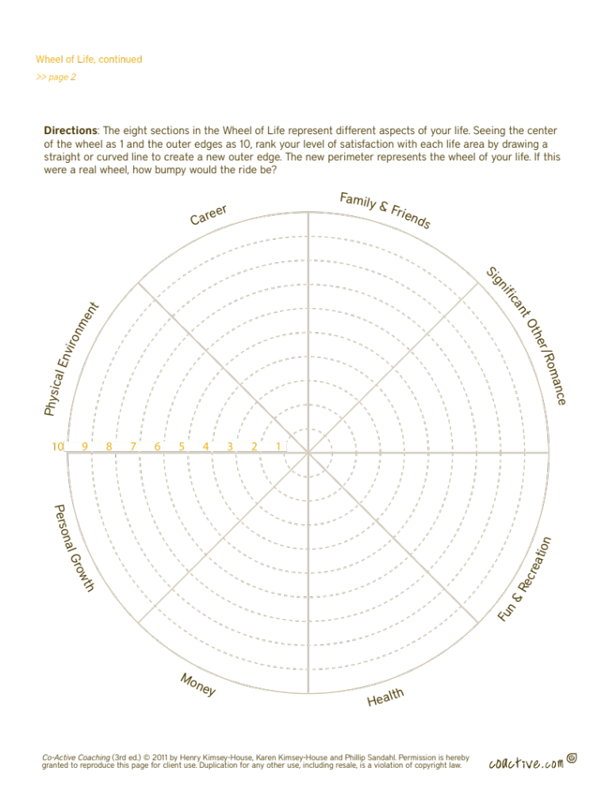

Appendix 3 – Job Wheel
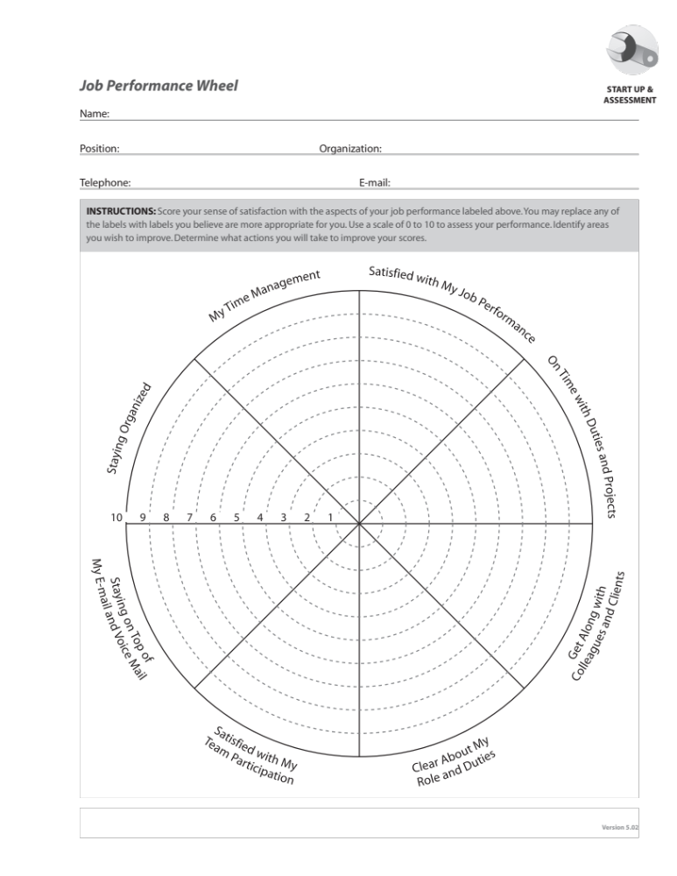
Actions for this Exercise, please move the star to give yourself a score on the Professional or Job wheel below; the score should represent where you are relative to your own goals. Choose three that need attention and start putting plans in place to close only three of the gaps you have. Remain focused on only 3, complete them, then move to your next areas. Reach out to others to help you in your quest for improvement.

Appendix 4 - The P.I.E. Model
This will all help you with the three things that are important for your career:
- Performance – you are getting better results with better ideas and building relationships along the way. Confidence is the key – I am confident I need help and that you can help me. I can also learn and do the work.
- Image – you are a collaborative, open minded, results based person who is getting exposure to great people the entire time. Be you! Be humble, be appreciative of your mentors.
- Exposure – Get ideas from smarter people! (higher levels) And thank them with results. Crafting a monthly one page letter has been very helpful in getting exposure to your business (not you) the key is to include your businesses priorities, business results, what help your business needs? Money? People? Resources? This is how you get it and update the people who gave that to you on the results of their choice to help you!

Appendix 5 Define your 5 big roles in your life!
Imagine a jar, you have 5 rocks that represent the big priorities in your life, you also have sand, gravel, water etc. If you put the sand and gravel in first, you will not be able to put the big important rocks into the jar. Instead, you should define and plan the 5 big rocks in your life and put them into the jar, then there is plenty of room for the gravel, sand and water. Do this at work and in your life. For me, these are my 5 roles in order:

Health
  - starts from the inside out – if I let this go, I can’t do the other roles well or with the right energy.

Husband
  - the kids know not to interrupt us, we go away alone, we spend time together, we invest in couples coaching, we update our goals, align our values regularly; we are doing all we can to maintain and build a strong connection for the future. I am also looking to role model what an ideal husband would be for them and that perspective helps me define what a successful husband is.

Father
  - This is a priority for me! I will be there for their games, I will take them out for lunch on their birthday, I will talk with them each night and help them with their homework and decisions. I will also push them out of the nest, provide challenge for them and help them believe in themselves.

Son/Friend/Brother
  - there is a tough trade-off here in that I give each of these 1/3 of what they want. This is deliberate and necessary to focus in the other areas that are important to me.

Leader
  - This is a passion area for me is linked to my life’s purpose: a teammate on the filed of battle inspiring others to be who they were born to be! To accomplish this, I have developed a leadership philosophy to help with that.
    - Vision
    - Team
    - Personal Development
    - Authenticity / Accountability
    - Discipline

Congratulations! you have defined your values, clarified your action plan areas for personal and professional life and you have prioritized your roles! Now plan your work and work your plan! Good Luck!
Let me know how I can help!

